***Pastors Lufile and Fariala Ehambe*** are ordained Ministers with the Australian Fellowship of Faith Churches and Ministries.  He is also an ordained minister with Trinity Christian Center of San Marcos, California.  He is licensed with World Ministry Fellowship of Dallas, Texas and served as a representative for Africa with Trinity Broadcasting Network.  Pastor Lufile Kasongo Ehambe and Fariala M. Ehambe are the Senior Pastors of the Christ International Churches in different parts of the world: Mainz-Germany, Brussels-Belgium, Kinshasa-Democratic Republic of Congo and in the Dallas/Fort Worth Metroplex , home of Christ International Church(CIC). God uses them in the ministry of Praise, Worship and Deliverance.

***Pastors Aubrey and Barbara Ector*** are the founding pastors of Unity Christian Ministries (UCM), Cleveland, TN since 2003. They are natives of Memphis, TN. He has been in the preaching ministry since 1987. He has served as a youth minister and has led churches as a senior pastor since 1990. Pastor Ector is a prolific writer and has written devotionals, Sunday school literature for a major Pentecostal denomination, and has also published a Christian fiction novel entitled, Second Chances. He is passionate about preaching and teaching the Word of God and believes the mission of the church is two fold, evangelism and discipleship. He is an active part of the prayer movement in Cleveland, TN and leads a group of Pastors and Intercessors who meet every Sunday morning at 8 am for an hour of prayer. The Ectors’ are true leaders who lead by example and live Holy Spirit empowered lives.

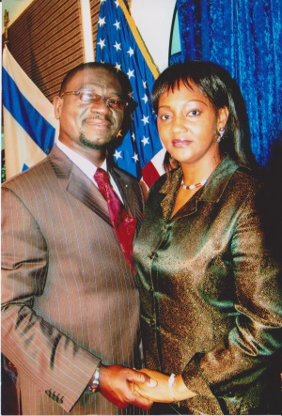 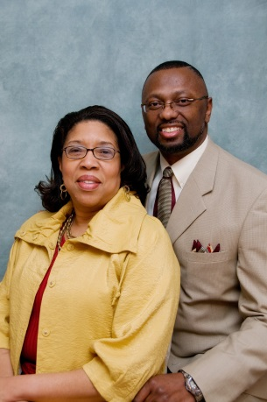

To contact these ministers for speaking engagements contact:

[www.onekeyministries.org](http://www.onekeyministries.org/) and post a contact us note.

***Deliverance is 180 degree repentance***